Application Testing Permission Document
This document acknowledges that the owner of the application grants full permission to the QA Testing Team to perform manual testing on the SlideSpark mobile application for Quality Assurance (QA) purposes.
The permission includes:
• Functional Testing
• UI/UX Assessment
• Regression Testing
• Performance & Usability Evaluation
The testing team is authorized to identify, report, and document any issues found during the QA process.
The app owner confirms that the testing activities will not harm or manipulate real user data and will be carried out under controlled testing guidelines.

Owner Details
Owner Name: Saifullah Anik
Contact No. / Email: sanik4144@gmail.com

Authorization Statement
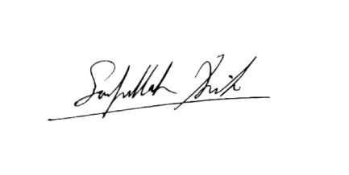
I, the undersigned, confirm that I am the authorized owner of this application and hereby allow QA testers to perform the above-mentioned testing activities on the SlideSpark App.

Signature of App Owner:
Date: 21 November 2025
Authorized for QA Testing Only

